Class For Node Function for display
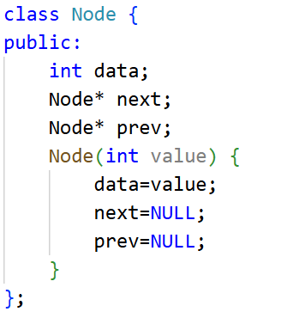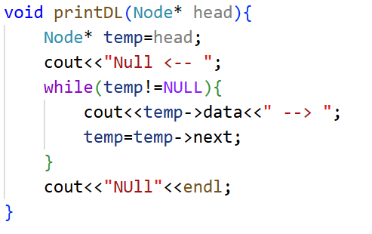

- Modify deleteAtPosition() to handle deletion from the last position without calling deleteAtEnd()
.CODE:
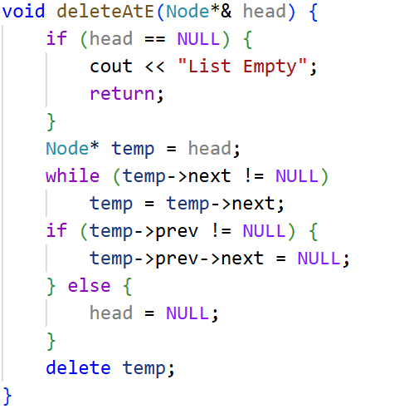

Output:
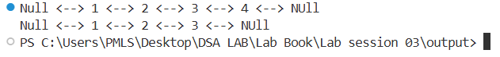

2. Write a function to delete all nodes with a given value..
CODE:
void deleteAllWith(Node*& head, int value) {
if (head == NULL) {
cout << "List Empty" << endl;
return;
}

Node* curr = head;
while (curr != NULL) {
Node* nextNode = curr->next;
if (curr->data == value) {
if (curr->prev == NULL) {
head = curr->next;
if (head != NULL)
head->prev = NULL;
} else {
curr->prev->next = curr->next;
}
if (curr->next != NULL) {
curr->next->prev = curr->prev;
}
delete curr;
}
curr = nextNode;
}
}
int main()
{
Node* head=new Node(3);
Node* second=new Node(2);
Node* third=new Node(3);
Node* forth=new Node(3);
head->next=second;
second->prev=head;
second->next=third;
third->prev=second;
third->next=forth;
forth->prev=third;
printDL(head);
deleteAllWith(head, 3);
printDL(head);

}

Output:
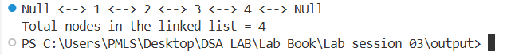

- Implement a function to clear the entire list.

CODE:

void clearList(Node*& head) {
Node* curr = head;

while (curr != NULL) {
Node* nextNode = curr->next;
delete curr;
curr = nextNode;
}

head = NULL;
}

int main()
{
Node* head=new Node(3);
Node* second=new Node(2);
Node* third=new Node(3);
Node* forth=new Node(3);
head->next=second;
second->prev=head;
second->next=third;
third->prev=second;
third->next=forth;
forth->prev=third;
printDL(head);
clearList(head);
printDL(head);

}

OUTPUT:

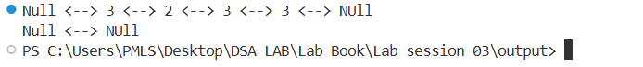
- Write a function to count and return the number of nodes after each deletion..

CODE:

int countNodes(Node* head) {
int count = 0;
Node* temp = head;
while (temp != NULL) {
count++;
temp = temp->next;
}
return count;
}
int main() {
Node* head = NULL;

insertAtB(head, 10);
insertAtB(head, 20);
insertAtE(head, 30);
insertAtPos(head, 1, 40);
printDL(head);
deleteAtB(head);
cout << "Nodes left: " << countNodes(head) << endl;
deleteAtE(head);
cout << "Nodes left: " << countNodes(head) << endl;
deleteAtPosition(head, 1);
return 0;
}

OUTPUT:
